

A

MINOR PROJECT

ON

“K-TREE BOUTIQUE HOTEL”

(IN HTML AND CSS)

SUBMITTED TO

BHARATI VIDYAPEETH INSTITUTE OF MANAGEMENT, KOLHAPUR.

FOR THE PARTIAL FULLFILLMENT OF

BACHELOR’S OF COMPUTER APPLICATION (BCA- III, SEM-V)

BY

Miss. SHRUTI GAIKWAD

Miss. SANIYA SAYYAD

Mr. NITIKET YADAV

UNDER GUIDANCE OF

Asst Prof. Kishori Budhale

THROUGH

THE DIRECTOR

BHARATI VIDYAPEETH INSTITUTE OF MANAGEMENT

KOLHAPUR

2023-2024



BHARATI VIDYAPEETH DEEMED TO BE UNIVERSITY INSTITUTE OF MANAGEMENT, KOLHAPUR.

DIRECTOR’S RECOMMENDATION

To,

The Director,

Bharati Vidyapeeth University, Kolhapur.

SUB: Request for approval of BCA-III (Sem- V) project report.

Sir,

I recommend the project report entitled “K-Tree Boutique Hotel” prepared by Miss. Shruti Gaikwad, Miss. Saniya Sayyad and Mr. Nitiket Yadav under the guidance of Asst Prof. Kishori Budhale Sawardeka as per practical fulfilment of university requirements for the award of partial fulfilment of Bachelors of Computer Application (BCA -III) degree of Bharati Vidyapeeth Institute of Management, Kolhapur.

Thanking You,

Dr.Rajesh Kanthe

Place: Kolhapur

(DIRCTOR)

Date:



BHARATI VIDYAPEETH UNIVERSITY INSTITUTE OF MANAGEMENT KOLHAPUR.

GUIDE’S CERTIFICATE

This is to certify that Miss. Shruti Gaikwad, Miss. Saniya Sayyad and Mr.Nitiket Yadav under the guidance of Asst Prof. Kishori Budhale Sawardeka have satisfactorily completed the project work on “K-Tree Boutique Hotel” of partial fulfilment of Bachelors of Computer Application (BCA) degree of Bharati Vidyapeeth Institute of Management, Kolhapur during the academic year 2023-24.

To the best of my knowledge & belief the matter presented by them is original & not copied for any source. Also, this report has not been submitted earlier for the award of partial fulfilment of any Degree or Diploma of Bharati Vidyapeeth University or any other University.

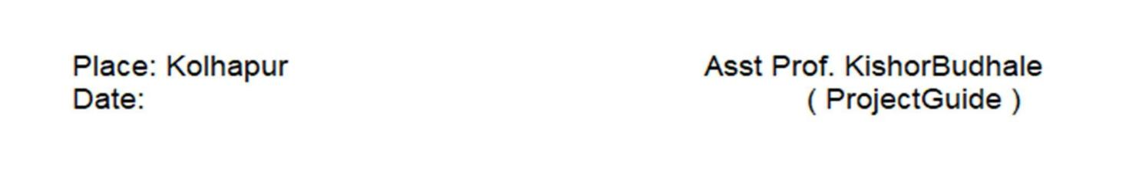



BHARATI VIDYAPEETH UNIVERSITY INSTITUTE OF

MANAGEMENT KOLHAPUR.

DECLARATION

We undersigned hereby declare that the project “K-Tree Boutique Hotel” entitled developed in html and css as per prescribed by Bharati Vidyapeeth Institute of Management Kolhapur, during the academic year 2023-24 under the guidance of Asst Prof. Kishori Budhale Sawardeka. The project presented is developed by us independently and is not duplication from any other source. We understand that any such copying is liable to be punishable in any way by the University authorities deem it.

The work is hereby submitted to Bharati Vidyapeeth

Deemed to be university for the practical fulfilment of BCA-III (SemV).

Place: Kolhapur Date:

Miss. Shruti Gaikwad Miss. Saniya Sayyad Mr. Nitiket Yadav



BHARATI VIDYAPEETH UNIVERSITY INSTITUTE OF

MANAGEMENT KOLHAPUR.

CERTIFICATE

This to certify that Miss. Shruti Gaikwad, Miss. Saniya Sayyad and Mr. Nitiket Yadav bearing the “Bharati Vidyapeeth Deemed to be University, Institute of Management”, have successfully completed the project entitled “K-Tree Boutique Hotel” as part of the course curriculum in our organization. They have completed the project using visual studio code editor technologies under the guidance and supervision of Asst Prof. Kishori Budhale Sawardeka. They have completed the assigned project well within the time frame.

Prof.P.G.Tandale

Co-ordinator and HOD



BHARATI VIDYAPEETH UNIVERSITY INSTITUTE OF

MANAGEMENT KOLHAPUR.

ACKNOWLEDGEMENT

We have great pleasure while submitting this Minor Project report entitled

“K-Tree Boutique Hotel” in partial fulfilment of BCA –III (Sem V) Minor Project. While submitting this minor project I take the opportunity to thank to those directly & indirectly related to minor project work, without their active co-operation & guidance it would have become extremely difficult to complete this task on time. I would like to express my highest regards to our Guide Asst Prof. Kishori Budhale Sawardeka for this enormous help.

Miss. Shruti Gaikwad Miss.Saniya Sayyad Mr. Nitiket Yadav

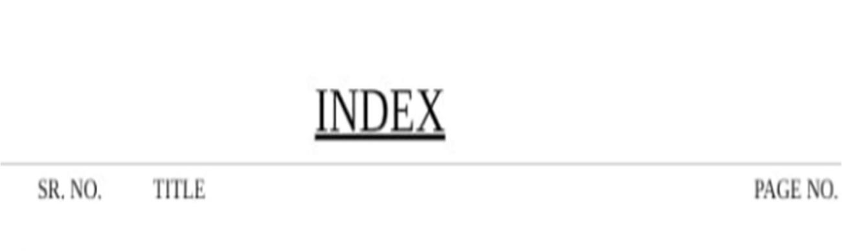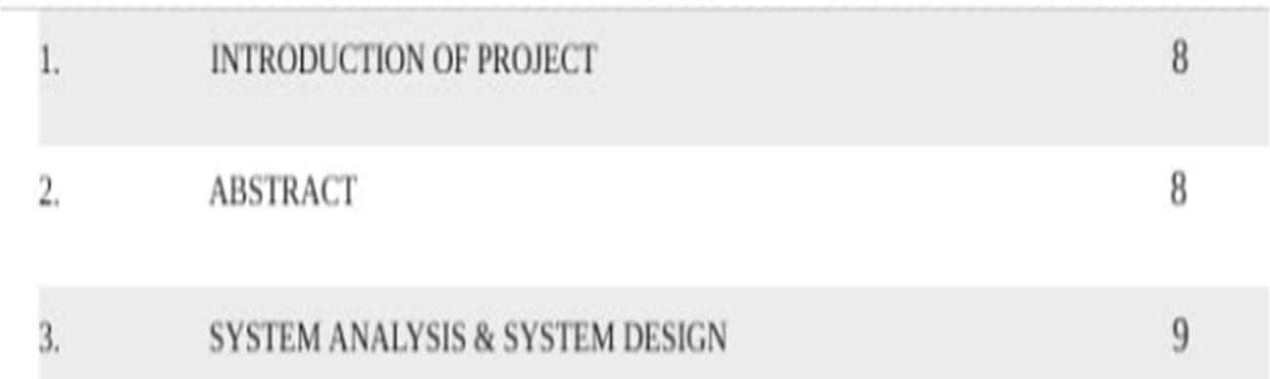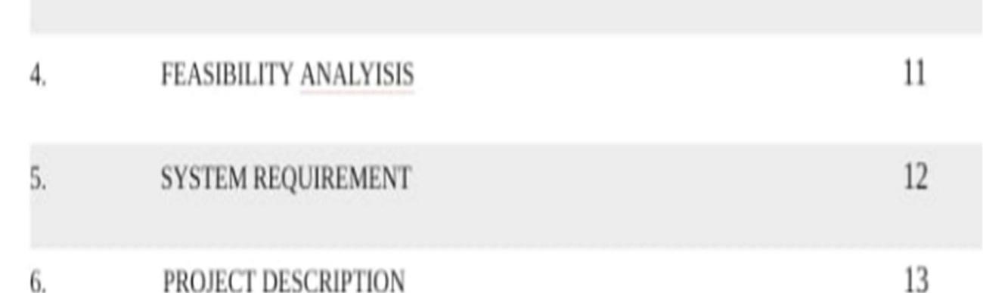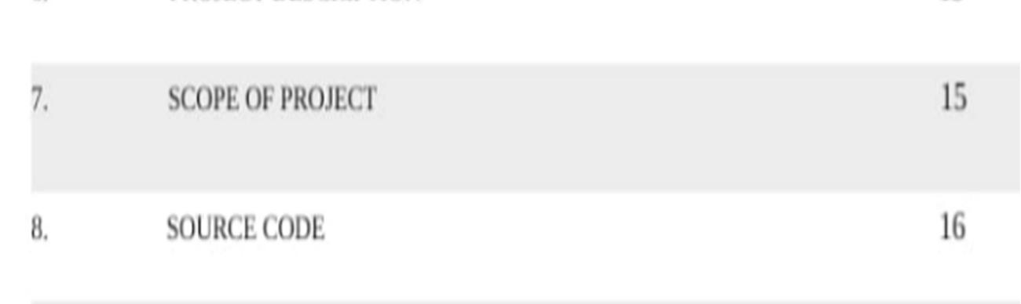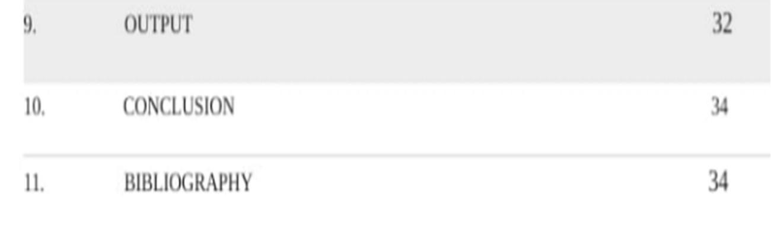

1. INTRODUCTION :- .

The “The K-Tree Boutique Hotel” project is a technological solution for creating lasting relationships between hotels and their guests. A boutique hotel is a small, intimate, and often independently-owned hotel that typically offers a unique and personalized experience for its guests. These establishments are known for their distinct character, attention to detail, and a strong emphasis on design and style.

It is an online platform created and maintained for hotel chain to provide information, facilitate bookings, and promote their services to potential guests. It serves as a digital representation of the hotel and are an essential component of the hotel's online presence.

An online booking system that enables guests to make reservations, select check-in and check-out

dates, and choose room preferences.

The primary objective of the project is to create an efficient and user-friendly web-based system for hotel guests to provide to make online reservation’s and booking’s. Compared to traditional methods like phone interviews, or in-person hotel reservation are usually more cost-effective to administrators because using traditional methods it costs time & efforts as well as the respondents may not be able to give accurate and thoughtful responses.

1. ABSTRACT:-

The purpose of the “K-Tree Boutique Hotel” is to provide detailed information about the hotel, including its location, amenities, room types, dining options, and services. This information helps potential guests make informed decisions about their stay.

The project is a digital solution designed to allow guests to make reservations and bookings online. This functionality streamlines the booking process, making it convenient for guests and reducing the workload for hotel staff.

The hotel website often features high-quality photos and virtual tours of the property. Visual content allows potential guests to get a sense of the hotel's atmosphere, décor, and overall appeal.

Website provide contact details, making it easy for guests to get in touch with the hotel for inquiries, special requests, or assistance.

Hotel websites are typically optimized for mobile devices, ensuring that guests can easily access information and make reservations from their smartphones or tablets.

Hotel websites invite guests to provide feedback or take satisfaction surveys, which can help the hotel improve its services and identify areas for enhancement.

It serves as a central hub for information, reservations, and communication between the hotel and its guests.

1. SYSTEM ANALYSIS:-

Existing System :-

The traditional methods of reserving rooms using register book or on calls can be inconvenient for the guest. Writing the whole data on a paper or in registers and handling all the material becomes difficult. Analysing the check-ins and check-outs of costumers and guests puts a load on the working staff. Digital forms are environmentally friendly, reducing the need for paper and the associated waste. Traditional methods of gathering information may still have their place, digital hotel website offers a more efficient, data-driven, and guest-centric approach that can lead to improved guest satisfaction and a competitive advantage in the hospitality industry.

Proposed System :-

The “K-Tree Boutique Hotel” has been successfully proposed for replacing the manual work of the collecting and storing data into the piece of paper. The implementation of hotel website saves the efforts and time of the user. It is the system where user just needs to input the value and it provides the result through output. Hence it is user friendly and easy to operate.

These objectives can be broken down into the following key points :-

⦁ To reduce the paper work.

⦁ To provide hotel management with the data and insights necessary to make informed decisions, allocate resources effectively, and prioritize areas for improvement

SYSTEM DESIGN:-

During analysis, the focus is on what needs to be done, independent of how it is done. During design, decisions are made about how the problem will be solved, first at high level, then at increasingly detailed levels, System design is the first design stage in which the basic approach to solving the problem is selected. During system design, the overall structure and style are decided. The system architecture is the overall organization of the system into components called subsystems. The architecture provides the context in which more detailed decisions are made in later design stages. By making high level decisions that apply to the entire system, the system designer partitions the problem into subsystems so that further work can be done by several designers working independently on different subsystems.

The system designer must make the following decisions:

⦁ Organize the system into subsystems.

⦁ Identify the concurrency inherent in the problem.

⦁ Allocate subsystems to processors and tasks.

⦁ Choose an approach for management of data stores.

⦁ Handle access to global resources.

⦁ Choose the implementation of control in software.

⦁ Handle boundary conditions.

4. Feasibility Analysis: -Types of Feasibility

a. Technical Feasibility:

During this study, the analyst identifies the existing computer systems of the concerned department and determines whether these technical resources are sufficient for the proposed system or not. If they are not sufficient, the analyst suggests the configuration of the computer systems that are required. The analyst generally pursues two or three different configurations which satisfy the key technical requirements but which represent different costs. During technical feasibility study, financial resources and budget is also considered b. Economic Feasibility:

Economic Feasibility the most important study that determines the cost and benefits of the proposed system and compares with the budget. The cost of the project should not outweigh the budget. The cost of the project includes the cost of hardware, software, development and implementation. Cost/benefit analysis is the common method to determine the benefits that are expected from the proposed system and compare them with the costs expected to spend on development of the system. c) Operational Feasibility:

When it is found that the project is both economic and technical feasible, the next step is to determine whether it is operationally feasible or not. During operational feasibility study, it is operationally feasible or not, during operational feasibility study, it is determined whether the system will operate in the way that user wants or not. Operational feasibility depends upon human resources for the development and implementation of the system. It is considered whether the qualified or experienced manpower is available for development and implementation of the system or not.

1. System Requirements:

♦ Hardware Requirements:

⦁ 256 MB Ram

⦁ 512 KB Cache Memory

⦁ Hard disk 10 GB

⦁ Mouse

♦ Software Requirements:

⦁ Operating System: Windows

Language: HTML, CSS

Compiler: V.S. CODE

1. PROJECT DESCRIPTION :

K-Tree Boutique Hotel system is a minor project used for guests and costumer. It is been programmed in HTML, CSS and JavaScript languages which makes it system independent. The K-Tree Boutique Hotel project is an initiative aimed at developing a comprehensive web-based platform for hotel to efficiently collect, allow guest, travellers

to search for, and book hotel accommodations. The Guests can filter options based on location, price, amenities and other preferences.

⦁ TOOLS AND METHODOLOGY:

The development of a hotel website project involves various tools and methodologies to ensure its success. Below are some of the commonly used tools and methodologies in such a project:

I. Integrated Development Environment (IDE): IDEs like Visual Studio Code are been used for coding and development. Visual Studio Code is a streamlined code editor with support for development operations like debugging, task running, and version control. It aims to provide just the tools a developer needs for a quick code-build-debug cycle and leaves more complex workflows to fuller featured IDEs, such as Visual Studio IDE Front-End Development: HTML, CSS, and JavaScript for creating the user interface and interactivity. HTML stands for Hypertext Markup Language. It is used to design web pages using a markup language. HTML is a combination of

Hypertext and Markup language. Hypertext defines the link between web pages. A markup language is used to define the text document within the tag which defines the structure of web pages. CSS stands for Cascading Style Sheets. It is a style sheet language which is used to describe the look and formatting of a document written in markup language. It provides an additional feature to HTML. JavaScript is a lightweight, cross-platform, single-threaded, and interpreted compiled programming language.

⦁ Methodology used for the project are as follows:

⦁ Responsive Web Design: Apply responsive web design principles to ensure the feedback form works seamlessly on various devices and screen sizes. ⦁ Security: Follow security best practices to protect guest data and ensure regulatory compliance.

⦁ Scalability: Consider scalability to ensure the system can handle an increasing volume of feedback submissions.

⦁ User Training and Documentation: Provide training and documentation for hotel staff to manage and respond to guest feedback effectively.

⦁ Feedback Loop: Establish a feedback loop within the development team and with hotel management to address concerns, make improvements, and measure the impact of changes.

Combining the right tools and methodologies is essential for the successful development and deployment of a hotel feedback form project, ensuring that..

7.SCOPE PROJECT :

The scope of a boutique hotel project encompasses various aspects, including its objectives, features, functionalities, and limitations. The primary objective is to create a user-friendly web-based system for guests/travellers to provide information about their hotel stay. The project aims to assess guest satisfaction, identify areas forimprovement, and enhance the overall guest experience project encompasses user registration and login for guests (optional but enhances data tracking and personalization). Data validation mechanisms are implemented to ensure data accuracy and integrity. Real-time response to guest feedback is enabled, allowing hotels to address concerns and make improvements promptly. Feedback data is securely stored in a database and linked to guest profiles (if registration is implemented). The project ensures the secure collection, storage, and handling of guest data, complying with data protection and privacy regulations. The project fosters a culture of continuous improvement, where feedback informs operational decisions, making services progressively better.

8.SOURCE CODE :

HTML PAGE’S

FIRST PAGE :-

<!DOCTYPE html>

<html lang="en">

<head>

<meta charset="UTF-8">

<meta http-equiv="X-UA-Compatible" content="IE=edge">

<meta name="viewport" content="width=device-width, initial-scale=1.0">

<title>Hotel Website</title>

<link rel="stylesheet" href="https://cdnjs.cloudflare.com/ajax/libs/font-awesome/6.0.0/css/all.min.css">

<link rel="stylesheet" href="https://cdn.jsdelivr.net/npm/swiper@9/swiper-bundle.min.css" />

<link rel="stylesheet" href="style.css">

<link rel="icon" href= "kTree.png" type="image/x-icon">

</head>

<body>

<!-- header -->

<header class="header">

<div>

<h1 id="logo">

<a href="index.html">

<img src="https://www.hotelktree.com/images/logo.png">

</a>

</h1>

<nav class="navbar">

<a href="about_us.html">About</a>

<a href="amenities.html">Amenities</a>

<a href="Accommodation.html">Accommodation</a>

<a href="How_To_Reach.html">How To Reach</a>

<a href="Photo_Gallery.html">gallery</a>

<a href="Restaurant.html">Restaurant</a>

<a href="FeedBack.html">Feedback</a>

<a href="Book.html" class="btn"> book now</a></h2>

</nav>

</div>

<div id="menu-btn" class="fas fa-bars"></div>

</header>

<!-- end -->

<!-- home -->

<section class="home" id="home">

<div class="swiper home-slider">

<div class="swiper-wrapper">

<div class="swiper-slide slide" style="background: url(https://www.hotelktree.com/images/headers/photo-gallery/img01.jpg) no-repeat;">

</div>

<div class="swiper-slide slide" style="background: url(https://www.hotelktree.com/images/headers/home-header/header02.jpg) no-repeat;">

</div>

<div class="swiper-slide slide" style="background: url(https://www.hotelktree.com/images/headers/home-header/header03.jpg) no-repeat;">

</div>

<div class="swiper-slide slide" style="background: url(https://www.hotelktree.com/images/headers/home-header/header04.jpg) no-repeat;">

</div>

<div class="swiper-slide slide" style="background: url(https://www.hotelktree.com/images/headers/home-header/header06.jpg) no-repeat;">

</div>

</div>

<div class="swiper-button-next"></div>

<div class="swiper-button-prev"></div>

</div>

</section>

<!-- about -->

<div class="homepage">

<div class="t">

<br>

<h2 class="title-anchor">Welcome to Hotel K Tree</h2>

<p>

<strong>K Tree is the Kolhapur cities first business cum boutique hotel</strong>

" providing the best in class convenience, comfort, luxury and modern amenities to its guests.

It beautifully blends luxury with comfort giving the travelers a place like home with ease to relax

after a hectic day of sightseeing or business meetings. We are pleased to introduce K Tree, a hotel

with 3 star facilities for business and tourist travelers in the heritage city of Kolhapur, under

company name of Darshani Hotels & Hospitality Services Pvt Ltd. Located in the heart of city of Kolhapur."

<a href="about_us.html" class="button-anchor">Read More</a>

</p>

</div>

</div>

<script src="https://cdn.jsdelivr.net/npm/swiper@9/swiper-bundle.min.js"></script>

<script src="script.js"></script>

</body>

</html>

**SECOND PAGE:-**

**<!DOCTYPE html>**

**<html lang="en">**

**<head>**

**<meta charset="UTF-8">**

**<meta http-equiv="X-UA-Compatible" content="IE=edge">**

**<meta name="viewport" content="width=device-width, initial-scale=1.0">**

**<title>Hotel Website</title>**

**<!-- font awesome cdn link -->**

**<link rel="stylesheet" href="https://cdnjs.cloudflare.com/ajax/libs/font-awesome/6.0.0/css/all.min.css">**

**<!-- swiper js cdn link -->**

**<link rel="stylesheet" href="https://cdn.jsdelivr.net/npm/swiper@9/swiper-bundle.min.css" />**

**<!-- custom css link -->**

**<link rel="stylesheet" href="style.css">**

**<link rel="icon" href= "kTree.png" type="image/x-icon">**

**</head>**

**<body>**

**<!-- header -->**

**<header class="header">**

**<div>**

**<h1 id="logo">**

**<a href="index.html">**

**<img src="https://www.hotelktree.com/images/logo.png">**

**</a>**

**</h1>**

**<nav class="navbar">**

**<a href="about_us.html">About</a>**

**<a href="amenities.html">Amenities</a>**

**<a href="Accommodation.html">Accommodation</a>**

**<a href="How_To_Reach.html">How To Reach</a>**

**<a href="Photo_Gallery.html">gallery</a>**

**<a href="Restaurant.html">Restaurant</a>**

**<a href="FeedBack.html">Feedback</a>**

**<a href="Book.html" class="btn"> book now</a></h2>**

**</nav>**

**</div>**

**<div id="menu-btn" class="fas fa-bars"></div>**

**</header>**

**<!-- end -->**

**<!-- home -->**

**<section class="home" id="home">**

**<div class="swiper home-slider">**

**<div class="swiper-wrapper">**

**<div class="swiper-slide slide" style="background: url(https://www.hotelktree.com/images/headers/about-us/img01.jpg) no-repeat;">**

**</div>**

**<div class="swiper-slide slide" style="background: url(https://www.hotelktree.com/images/headers/about-us/img02.jpg) no-repeat;">**

**</div>**

**<div class="swiper-slide slide" style="background: url(https://www.hotelktree.com/images/headers/about-us/img03.jpg) no-repeat;">**

**</div>**

**</div>**

**<div class="swiper-button-next"></div>**

**<div class="swiper-button-prev"></div>**

**</div>**

**</section>**

**<!-- about -->**

**<div class="homepage">**

**<div class="t">**

**<br>**

**<h2 class="title-anchor">About Us</h2>**

**<p>**

**"We are pleased to introduce "**

**<span class="text-bold">K Tree</span>**

**", a hotel with 3 star facilities for business and tourist travelers in the heritage**

**city of Kolhapur, under company name of "Darshani Hotels & Hospitality Services Pvt Ltd."**

**</p>**

**<p>"Located in the heart of city of Kolhapur and just 2 mins away from Central Bus Stand and 5 mins from the Railway Station, the "**

**<span class="text-bold">K Tree</span>**

**" Hotel offers peace and privacy of home with the warmth and personal welcome you would expect from a hotel committed to**

**excellence."**

**</p>**

**<p>**

**<span class="text-bold">K Tree</span>**

**" is the Kolhapur cities "**

**<span class="text-bold">first business cum boutique hotel</span>**

**" providing the best in class convenience, comfort, luxury and modern amenities to its guests.**

**It beautifully blends luxury with comfort giving the travelers a place like home with ease to relax**

**after a hectic day of sightseeing or business meetings."**

**</p>**

**<p>**

**<span class="text-bold">K Tree</span>**

**" offers large spacious 26 rooms, a multi-cuisine restaurant, conference hall and a terrace party**

**venue for various events and ceremonies. All the rooms are equipped with best in class modern amenities like A.C.,**

**LCD TV’s, Electronic Safe Lockers, Rain showers and many more facilities. The hotel is also equipped with CCTV**

**surveillance and Smoke & Fire alarms for safety of our guests."**

**</p>**

**</div>**

**</div>**

**<div class="homepage">**

**<div class="t">**

**<br>**

**<h2 class="title-anchor">Amenities</h2>**

**<div class="containerr">**

**<ul class="content_inLi">**

**<li><a href="amenities.html">AC Rooms</a></li>**

**<li><a href="amenities.html">Complimentary Breakfast</a></li>**

**<li><a href="amenities.html">24 Hrs Power Back Up</a></li>**

**<li><a href="amenities.html">Complimentary Wi-Fi Internet Facility</a></li>**

**<li><a href="amenities.html">24 Hrs Room Service</a></li>**

**<li><a href="amenities.html">LCD TV in all Rooms</a></li>**

**<li><a href="amenities.html">Safety Lockers Available</a></li>**

**<li><a href="amenities.html">In House Parking & Valet Parking</a></li>**

**<li><a href="amenities.html">Multi-cuisine Restaurant</a></li>**

**<li><a href="amenities.html">Banquet and Conference Facility</a></li>**

**<li><a href="amenities.html">Maharashtra Express Theme Terrace Restaurant</a></li>**

**</ul>**

**</div>**

**</div>**

**</div>**

**</div>**

**<script src="https://cdn.jsdelivr.net/npm/swiper@9/swiper-bundle.min.js"></script>**

**<script src="script.js"></script>**

**</body>**

**</html>**

**THIRD PAGE:-**

**<!DOCTYPE html>**

**<html lang="en">**

**<head>**

**<meta charset="UTF-8">**

**<meta http-equiv="X-UA-Compatible" content="IE=edge">**

**<meta name="viewport" content="width=device-width, initial-scale=1.0">**

**<title>Hotel Website</title>**

**<!-- font awesome cdn link -->**

**<link rel="stylesheet" href="https://cdnjs.cloudflare.com/ajax/libs/font-awesome/6.0.0/css/all.min.css">**

**<!-- swiper js cdn link -->**

**<link rel="stylesheet" href="https://cdn.jsdelivr.net/npm/swiper@9/swiper-bundle.min.css" />**

**<!-- custom css link -->**

**<link rel="stylesheet" href="style.css">**

**<link rel="icon" href= "kTree.png" type="image/x-icon">**

**</head>**

**<body>**

**<!-- header -->**

**<header class="header">**

**<div>**

**<h1 id="logo">**

**<a href="index.html">**

**<img src="https://www.hotelktree.com/images/logo.png">**

**</a>**

**</h1>**

**<nav class="navbar">**

**<a href="about_us.html">About</a>**

**<a href="amenities.html">Amenities</a>**

**<a href="Accommodation.html">Accommodation</a>**

**<a href="How_To_Reach.html">How To Reach</a>**

**<a href="Photo_Gallery.html">gallery</a>**

**<a href="Restaurant.html">Restaurant</a>**

**<a href="FeedBack.html">Feedback</a>**

**<a href="Book.html" class="btn"> book now</a></h2>**

**</nav>**

**</div>**

**<div id="menu-btn" class="fas fa-bars"></div>**

**</header>**

**<!-- end -->**

**<!-- home -->**

**<section class="home" id="home">**

**<div class="swiper home-slider">**

**<div class="swiper-wrapper">**

**<div class="swiper-slide slide" style="background: url(https://www.hotelktree.com/images/headers/amenities/img01.jpg) no-repeat;">**

**</div>**

**<div class="swiper-slide slide" style="background: url(https://www.hotelktree.com/images/headers/amenities/img02.jpg) no-repeat;">**

**</div>**

**<div class="swiper-slide slide" style="background: url(https://www.hotelktree.com/images/headers/amenities/img03.jpg) no-repeat;">**

**</div>**

**</div>**

**<div class="swiper-button-next"></div>**

**<div class="swiper-button-prev"></div>**

**</div>**

**</section>**

**<!-- about -->**

**<div class="homepage">**

**<div class="t">**

**<br>**

**<h2 class="title-anchor">Amenities</h2>**

**<p>**

**The K Tree offers a variety of services and facilities to suit the requirements of**

**all our guests visiting either for business or leisure activities to the heritage city of Kolhapur.**

**</p>**

**<p>**

**K Tree offers large spacious 26 rooms that offer our guest plenty of variety to choose**

**from and an ambience to provide a pleasurable stay with us.**

**</p>**

**<img src="https://www.hotelktree.com/images/amenities-img1.jpg">**

**</div>**

**<script src="https://cdn.jsdelivr.net/npm/swiper@9/swiper-bundle.min.js"></script>**

**<script src="script.js"></script>**

**</body>**

**</html>**

**FOURTH PAGE:-**

**<!DOCTYPE html>**

**<html lang="en">**

**<head>**

**<meta charset="UTF-8">**

**<meta http-equiv="X-UA-Compatible" content="IE=edge">**

**<meta name="viewport" content="width=device-width, initial-scale=1.0">**

**<title>Hotel Website</title>**

**<!-- font awesome cdn link -->**

**<link rel="stylesheet" href="https://cdnjs.cloudflare.com/ajax/libs/font-awesome/6.0.0/css/all.min.css">**

**<!-- swiper js cdn link -->**

**<link rel="stylesheet" href="https://cdn.jsdelivr.net/npm/swiper@9/swiper-bundle.min.css" />**

**<!-- custom css link -->**

**<link rel="stylesheet" href="style.css">**

**<link rel="icon" href= "kTree.png" type="image/x-icon">**

**</head>**

**<body>**

**<!-- header -->**

**<header class="header">**

**<div>**

**<h1 id="logo">**

**<a href="index.html">**

**<img src="https://www.hotelktree.com/images/logo.png">**

**</a>**

**</h1>**

**<nav class="navbar">**

**<a href="about_us.html">About</a>**

**<a href="amenities.html">Amenities</a>**

**<a href="Accommodation.html">Accommodation</a>**

**<a href="How_To_Reach.html">How To Reach</a>**

**<a href="Photo_Gallery.html">gallery</a>**

**<a href="Restaurant.html">Restaurant</a>**

**<a href="FeedBack.html">Feedback</a>**

**<a href="Book.html" class="btn"> book now</a></h2>**

**</nav>**

**</div>**

**<div id="menu-btn" class="fas fa-bars"></div>**

**</header>**

**<!-- end -->**

**<!-- home -->**

**<section class="home" id="home">**

**<div class="swiper home-slider">**

**<div class="swiper-wrapper">**

**<div class="swiper-slide slide" style="background: url(https://www.hotelktree.com/images/headers/accommodations/img03.jpg) no-repeat;">**

**</div>**

**<div class="swiper-slide slide" style="background: url(https://www.hotelktree.com/images/headers/accommodations/img02.jpg) no-repeat;">**

**</div>**

**<div class="swiper-slide slide" style="background: url(https://www.hotelktree.com/images/headers/accommodations/img01.jpg) no-repeat;">**

**</div>**

**</div>**

**<div class="swiper-button-next"></div>**

**<div class="swiper-button-prev"></div>**

**</div>**

**</section>**

**<!-- about -->**

**<div class="homepage">**

**<div class="t">**

**<br>**

**<h2 class="title-anchor">Accommodation</h2>**

**<p>**

**<span class="text-bold">K Tree</span>**

**" has stylish and spacious deluxe and super deluxe rooms thoughtfully designed to provide the optimum**

**balance between work, relaxation, leisure and a comfortable sleep. "**

**<span class="text-bold">K Tree</span>**

**" also offers unique themed residence suites (Monochrome, Elegance and Rustic), which will**

**take you on a journey through distinctive trend."**

**</p>**

**<a id="suite" name="suite"></a>**

**<h2 class="suitroom">SUITE ROOMS</h2>**

**<br>**

**<h4>Monochrome</h4>**

**<br>**

**<img src="https://www.hotelktree.com/images/monochrome-img01.jpg">**

**<p>**

**"Located towards the front side of property, this suite room is conceptualized in a western**

**style with elements in shades of black and white exclusively, having a very modern and Zen outlook.**

**This suite is one of our largest, most indulgent room; perfect for working, marking a special occasion**

**or enjoying a longer stay. The newspaper print European folding blinds and black & white themed wallpaper**

**reflects a timeless combination and adds an instant touch of drama to the space."**

**</p>**

**<p>**

**The room has a king-size bed with one side glass bottom led light effects to enhance your pleasure. It is also fitted with a**

**modern glass wardrobe, a lounge with sofa and a bar area. This is boasted by 2 LED TV’s in bedroom and lounge area for you to decide where**

**to enjoy. The large bathroom features a walk in rain shower, luxurious fixtures, and contemporary toiletry accessories and a hair dryer.**

**</p>**

**<br>**

**<h4>Elegance</h4>**

**<br>**

**<img src="https://www.hotelktree.com/images/elegance-img03.jpg">**

**<p>**

**Suite room conceptualised in a neo-classic style with elements in beige and wooden finish with**

**floral motifs and has a very cozy and warm outlook. This suite is one of our largest, most indulgent**

**room; perfect for working, marking a special occasion or enjoying a longer stay. A Royal theme and Four**

**poster bed enhances the décor of this suite.**

**</p>**

**<p>**

**This suite is equipped with a King size four poster bed, an elegant wardrobe, a lounge with sofa and a bar area.**

**A full glass view with European folding blinds, it is overlooking the front side of the property. This is boasted by 2**

**LED TV’s in bedroom and lounge area for you to decide where to enjoy. Sophisticated golden yellow wallpapers gives a classy**

**flavor to the décor.The large bathroom features a walk in rain shower, luxurious fixtures, and**

**contemporary toiletry accessories and a hair dryer.**

**</p>**

**<br>**

**<h4>Rustic</h4>**

**<br>**

**<img src="https://www.hotelktree.com/images/rustic-img02.jpg">**

**<p>**

**This suite room is conceptualized in an earthen style with elements in terracotta and wooden finish with**

**mud walls, having a very Indian outlook. Uniquely designed this suite has rustic style's unpretentious roots,**

**organic textures and shapes, natural warmth and yet with modern amenities.**

**</p>**

**<p>**

**The King size bed with an extended area provides that extra space to chill out. Distinctive crisscross designed large wardrobe, a**

**lounge with sofa, a rustic wooden center table and a minibar area with a high chair adds to that additional feature’s in the room.**

**This is boasted by 2 LED TV’s in bedroom and lounge area for you to decide where to enjoy. The large bathroom features a**

**stone carved washbasin that can spark creativity. It also has a walk in rain shower, luxurious fixtures, contemporary toiletry**

**accessories and a hair dryer.**

**</p>**

**<br>**

**<h2 class="suitroom">DELUXE ROOMS</h2>**

**<br>**

**<img src="https://www.hotelktree.com/images/super-deluxe-rooms-img01.jpg">**

**<p>**

**"The deluxe rooms are designed in a very boutique way that is furnished in a themed, stylish and aspirational manner.**

**These spacious rooms have been modernly designed considering needs of all our guests to the hotel and also have large**

**bathrooms with all the modern fixtures. With rooms spread across four floors and different themes on 2 floors, you will have**

**plenty more to explore in your every visit.**

**</p>**

**<p>**

**With large queen size beds and a very comfortable mattress you are guaranteed to have a relaxed and pleasurable stay.**

**The rooms are uniquely merged visually into the bathroom with glass at ceiling level thus enhancing the total space.**

**We offer complimentary breakfast, high speed internet, study table, LED TV, safety lockers, mini bar and AC in each room.**

**</p>**

**<br>**

**</div>**

**</div>**

**</div>**

**<script src="https://cdn.jsdelivr.net/npm/swiper@9/swiper-bundle.min.js"></script>**

**<script src="script.js"></script>**

**</body>**

**</html>**

**FIVE PAGE:-**

**<!DOCTYPE html>**

**<html lang="en">**

**<head>**

**<meta charset="UTF-8">**

**<meta http-equiv="X-UA-Compatible" content="IE=edge">**

**<meta name="viewport" content="width=device-width, initial-scale=1.0">**

**<title>Hotel Website</title>**

**<!-- font awesome cdn link -->**

**<link rel="stylesheet" href="https://cdnjs.cloudflare.com/ajax/libs/font-awesome/6.0.0/css/all.min.css">**

**<!-- swiper js cdn link -->**

**<link rel="stylesheet" href="https://cdn.jsdelivr.net/npm/swiper@9/swiper-bundle.min.css" />**

**<!-- custom css link -->**

**<link rel="stylesheet" href="style.css">**

**<link rel="icon" href= "kTree.png" type="image/x-icon">**

**</head>**

**<body>**

**<!-- header -->**

**<header class="header">**

**<div>**

**<h1 id="logo">**

**<a href="index.html">**

**<img src="https://www.hotelktree.com/images/logo.png">**

**</a>**

**</h1>**

**<nav class="navbar">**

**<a href="about_us.html">About</a>**

**<a href="amenities.html">Amenities</a>**

**<a href="Accommodation.html">Accommodation</a>**

**<a href="How_To_Reach.html">How To Reach</a>**

**<a href="Photo_Gallery.html">gallery</a>**

**<a href="Restaurant.html">Restaurant</a>**

**<a href="FeedBack.html">Feedback</a>**

**<a href="Book.html" class="btn"> book now</a></h2>**

**</nav>**

**</div>**

**<div id="menu-btn" class="fas fa-bars"></div>**

**</header>**

**<!-- end -->**

**<!-- home -->**

**<section class="home" id="home">**

**<div class="swiper home-slider">**

**<div class="swiper-wrapper">**

**<div class="swiper-slide slide" style="background: url(https://www.hotelktree.com/images/headers/how-to-reach/img01.jpg) no-repeat;">**

**</div>**

**<div class="swiper-slide slide" style="background: url(https://www.hotelktree.com/images/headers/how-to-reach/img02.jpg) no-repeat;">**

**</div>**

**<div class="swiper-slide slide" style="background: url(https://www.hotelktree.com/images/headers/how-to-reach/img03.jpg) no-repeat;">**

**</div>**

**</div>**

**<div class="swiper-button-next"></div>**

**<div class="swiper-button-prev"></div>**

**</div>**

**</section>**

**<!-- about -->**

**<div class="homepage">**

**<div class="t">**

**<br>**

**<h2 class="title-anchor">How to Reach</h2>**

**<p>**

**Located in the heart of city and only 8 kms from the airport,**

**The K Tree Hotel, is about 15 minute drive from the airport and about 5**

**minute drive from the Chatrapati Shahu Maharaj Kolhapur Railway station.**

**The hotel is just 2KM away from Pune – Bangalore NH4 national highway which**

**provides excellent connectivity to all the commuters via Kolhapur.**

**</p>**

**<h2 class="suitroom">By Air</h2>**

**<br>**

**<p>**

**Kolhapur airport has direct flights from Mumbai. Hotel K Tree is just 9**

**KM away from the airport which is approximately 15 minute drive to the Hotel.**

**</p>**

**<h2 class="suitroom">By Rail</h2>**

**<br>**

**<p>**

**Shri Chatrapati Shahu Maharaj Terminus is very well connected and has 3 daily services to and fro from Mumbai.**

**It is also well connected to Southern & other parts of the country. Hotel K Tree is just 1.5 kms away from the**

**railway station – which is just a 5 minute drive.**

**</p>**

**<br>**

**<h2 class="suitroom">By Road</h2>**

**<br>**

**<p>**

**This Hotel is just 1 kms away from the central bus stand and also just 2 kms away from NH4 (Pune – Bangalore) highway**

**which provides excellent connectivity to all visitors to Kolhapur and also as stop over for by-passers on the highway.**

**</p>**

**<br>**

**<h2 class="suitroom">Direction</h2>**

**<br>**

**<p>**

**Travel from Airport & Railway Station & Bus Stand to Hotel**

**</p>**

**<br>**

**<a href="https://goo.gl/maps/Rpq4D" target="_blank">**

**<img src="https://www.hotelktree.com/images/img-howtoreach.jpg" class="content">**

**</a>**

**</div>**

**</div>**

**<div class="homepage">**

**<div class="t">**

**<br>**

**<h2 class="title-anchor">Amenities</h2>**

**<div class="containerr">**

**<ul class="content_inLi">**

**<li><a href="amenities.html">AC Rooms</a></li>**

**<li><a href="amenities.html">Complimentary Breakfast</a></li>**

**<li><a href="amenities.html">24 Hrs Power Back Up</a></li>**

**<li><a href="amenities.html">Complimentary Wi-Fi Internet Facility</a></li>**

**<li><a href="amenities.html">24 Hrs Room Service</a></li>**

**<li><a href="amenities.html">LCD TV in all Rooms</a></li>**

**<li><a href="amenities.html">Safety Lockers Available</a></li>**

**<li><a href="amenities.html">In House Parking & Valet Parking</a></li>**

**<li><a href="amenities.html">Multi-cuisine Restaurant</a></li>**

**<li><a href="amenities.html">Banquet and Conference Facility</a></li>**

**<li><a href="amenities.html">Maharashtra Express Theme Terrace Restaurant</a></li>**

**</ul>**

**</div>**

**</div>**

**</div>**

**</div>**

**<script src="https://cdn.jsdelivr.net/npm/swiper@9/swiper-bundle.min.js"></script>**

**<script src="script.js"></script>**

**</body>**

**</html>**

**SIXTH PAGE:-**

**<!DOCTYPE html>**

**<html lang="en">**

**<head>**

**<meta charset="UTF-8">**

**<meta http-equiv="X-UA-Compatible" content="IE=edge">**

**<meta name="viewport" content="width=device-width, initial-scale=1.0">**

**<title>Hotel Website</title>**

**<!-- font awesome cdn link -->**

**<link rel="stylesheet" href="https://cdnjs.cloudflare.com/ajax/libs/font-awesome/6.0.0/css/all.min.css">**

**<!-- swiper js cdn link -->**

**<link rel="stylesheet" href="https://cdn.jsdelivr.net/npm/swiper@9/swiper-bundle.min.css" />**

**<!-- custom css link -->**

**<link rel="stylesheet" href="style.css">**

**<link rel="icon" href= "kTree.png" type="image/x-icon">**

**</head>**

**<body>**

**<!-- header -->**

**<header class="header">**

**<div>**

**<h1 id="logo">**

**<a href="index.html">**

**<img src="https://www.hotelktree.com/images/logo.png">**

**</a>**

**</h1>**

**<nav class="navbar">**

**<a href="about_us.html">About</a>**

**<a href="amenities.html">Amenities</a>**

**<a href="Accommodation.html">Accommodation</a>**

**<a href="How_To_Reach.html">How To Reach</a>**

**<a href="Photo_Gallery.html">gallery</a>**

**<a href="Restaurant.html">Restaurant</a>**

**<a href="FeedBack.html">Feedback</a>**

**<a href="Book.html" class="btn"> book now</a></h2>**

**</nav>**

**</div>**

**<div id="menu-btn" class="fas fa-bars"></div>**

**</header>**

**<!-- end -->**

**<!-- home -->**

**<section class="home" id="home">**

**<div class="swiper home-slider">**

**<div class="swiper-wrapper">**

**<div class="swiper-slide slide" style="background: url(https://www.hotelktree.com/images/headers/photo-gallery/img01.jpg) no-repeat;">**

**</div>**

**<div class="swiper-slide slide" style="background: url(https://www.hotelktree.com/images/headers/photo-gallery/img02.jpg) no-repeat;">**

**</div>**

**<div class="swiper-slide slide" style="background: url(https://www.hotelktree.com/images/headers/photo-gallery/img03.jpg) no-repeat;">**

**</div>**

**</div>**

**<div class="swiper-button-next"></div>**

**<div class="swiper-button-prev"></div>**

**</div>**

**</section>**

**<!-- about -->**

**<div class="homepage">**

**<div class="t">**

**<br>**

**<a id="suite" name="suite"></a>**

**<h2 class="title-anchor">Photo Gallary</h2>**

**<br>**

**<h4>Reception Area</h4>**

**<br>**

**<div class="grid-container">**

**<div class="Reception_are"><img src="https://www.hotelktree.com/images/gallery/thumb/img001.jpg"></div>**

**<div class="Reception_are1"><img src="https://www.hotelktree.com/images/gallery/thumb/img041.jpg"></div>**

**<div class="Reception_are2"><img src="https://www.hotelktree.com/images/gallery/thumb/img004.jpg"></div>**

**</div>**

**<br>**

**<h4>Lobby</h4>**

**<br>**

**<div class="grid-container">**

**<div class="Reception_are"><img src="https://www.hotelktree.com/images/gallery/thumb/img002.jpg"></div>**

**<div class="Reception_are1"><img src="https://www.hotelktree.com/images/gallery/thumb/img038.jpg"></div>**

**<div class="Reception_are2"><img src="https://www.hotelktree.com/images/gallery/thumb/img040.jpg"></div>**

**</div>**

**<br>**

**<h4>Restaurant</h4>**

**<br>**

**<div class="grid-container">**

**<div><img src="https://www.hotelktree.com/images/gallery/thumb/img006.jpg"></div>**

**<div><img src="https://www.hotelktree.com/images/gallery/thumb/img007.jpg"></div>**

**<div><img src="https://www.hotelktree.com/images/gallery/thumb/img031.jpg"></div>**

**<div><img src="https://www.hotelktree.com/images/gallery/thumb/img032.jpg"></div>**

**<div><img src="https://www.hotelktree.com/images/gallery/thumb/img033.jpg"></div>**

**<div><img src="https://www.hotelktree.com/images/gallery/thumb/img034.jpg"></div>**

**<div><img src="https://www.hotelktree.com/images/gallery/thumb/img035.jpg"></div>**

**<div><img src="https://www.hotelktree.com/images/gallery/thumb/img036.jpg"></div>**

**<div><img src="https://www.hotelktree.com/images/gallery/thumb/img037.jpg"></div>**

**<div><img src="https://www.hotelktree.com/images/gallery/thumb/img039.jpg"></div>**

**</div>**

**<br>**

**<h4>Deluxe</h4>**

**<br>**

**<div class="grid-container">**

**<div><img src="https://www.hotelktree.com/images/gallery/thumb/img008.jpg"></div>**

**<div><img src="https://www.hotelktree.com/images/gallery/thumb/img009.jpg"></div>**

**<div><img src="https://www.hotelktree.com/images/gallery/thumb/img028.jpg"></div>**

**<div><img src="https://www.hotelktree.com/images/gallery/thumb/img029.jpg"></div>**

**<div><img src="https://www.hotelktree.com/images/gallery/thumb/img030.jpg"></div>**

**</div>**

**<br>**

**<h4>Super Deluxe</h4>**

**<br>**

**<div class="grid-container">**

**<div class="superDi"><img src="https://www.hotelktree.com/images/gallery/thumb/img005.jpg"></div>**

**</div>**

**<br>**

**<h4>Suite Rooms - Elegance</h4>**

**<br>**

**<div class="grid-container">**

**<div><img src="https://www.hotelktree.com/images/gallery/thumb/img043.jpg"></div>**

**<div><img src="https://www.hotelktree.com/images/gallery/thumb/img044.jpg"></div>**

**<div><img src="https://www.hotelktree.com/images/gallery/thumb/img045.jpg"></div>**

**<div><img src="https://www.hotelktree.com/images/gallery/thumb/img046.jpg"></div>**

**</div>**

**<br>**

**<h4>Suite Rooms - Monochrome</h4>**

**<br>**

**<div class="grid-container">**

**<div><img src="https://www.hotelktree.com/images/gallery/thumb/img011.jpg"></div>**

**<div><img src="https://www.hotelktree.com/images/gallery/thumb/img012.jpg"></div>**

**<div><img src="https://www.hotelktree.com/images/gallery/thumb/img013.jpg"></div>**

**<div><img src="https://www.hotelktree.com/images/gallery/thumb/img014.jpg"></div>**

**</div>**

**<br>**

**<h4>Suite Rooms - Rustic</h4>**

**<br>**

**<div class="grid-container">**

**<div><img src="https://www.hotelktree.com/images/gallery/thumb/img015.jpg"></div>**

**<div><img src="https://www.hotelktree.com/images/gallery/thumb/img017.jpg"></div>**

**<div><img src="https://www.hotelktree.com/images/gallery/thumb/img018.jpg"></div>**

**<div><img src="https://www.hotelktree.com/images/gallery/thumb/img020.jpg"></div>**

**<div><img src="https://www.hotelktree.com/images/gallery/thumb/img021.jpg"></div>**

**<div><img src="https://www.hotelktree.com/images/gallery/thumb/img023.jpg"></div>**

**<div><img src="https://www.hotelktree.com/images/gallery/thumb/img024.jpg"></div>**

**<div><img src="https://www.hotelktree.com/images/gallery/thumb/img025.jpg"></div>**

**</div>**

**</div>**

**</div>**

**<script src="https://cdn.jsdelivr.net/npm/swiper@9/swiper-bundle.min.js"></script>**

**<script src="script.js"></script>**

**</body>**

**</html>**

**SEVENTH PAGE:-**

**<!DOCTYPE html>**

**<html lang="en">**

**<head>**

**<meta charset="UTF-8">**

**<meta http-equiv="X-UA-Compatible" content="IE=edge">**

**<meta name="viewport" content="width=device-width, initial-scale=1.0">**

**<title>Hotel Website</title>**

**<!-- font awesome cdn link -->**

**<link rel="stylesheet" href="https://cdnjs.cloudflare.com/ajax/libs/font-awesome/6.0.0/css/all.min.css">**

**<!-- swiper js cdn link -->**

**<link rel="stylesheet" href="https://cdn.jsdelivr.net/npm/swiper@9/swiper-bundle.min.css" />**

**<!-- custom css link -->**

**<link rel="stylesheet" href="style.css">**

**<link rel="icon" href= "kTree.png" type="image/x-icon">**

**</head>**

**<body>**

**<!-- header -->**

**<header class="header">**

**<div>**

**<h1 id="logo">**

**<a href="index.html">**

**<img src="https://www.hotelktree.com/images/logo.png">**

**</a>**

**</h1>**

**<nav class="navbar">**

**<a href="about_us.html">About</a>**

**<a href="amenities.html">Amenities</a>**

**<a href="Accommodation.html">Accommodation</a>**

**<a href="How_To_Reach.html">How To Reach</a>**

**<a href="Photo_Gallery.html">gallery</a>**

**<a href="Restaurant.html">Restaurant</a>**

**<a href="FeedBack.html">Feedback</a>**

**<a href="Book.html" class="btn"> book now</a></h2>**

**</nav>**

**</div>**

**<div id="menu-btn" class="fas fa-bars"></div>**

**</header>**

**<!-- end -->**

**<!-- home -->**

**<section class="home" id="home">**

**<div class="swiper home-slider">**

**<div class="swiper-wrapper">**

**<div class="swiper-slide slide" style="background: url(https://www.hotelktree.com/images/headers/dinning/img02.jpg) no-repeat;">**

**</div>**

**<div class="swiper-slide slide" style="background: url(https://www.hotelktree.com/images/headers/dinning/img02.jpg) no-repeat;">**

**</div>**

**<div class="swiper-slide slide" style="background: url(https://www.hotelktree.com/images/headers/dinning/img03.jpg) no-repeat;">**

**</div>**

**</div>**

**<div class="swiper-button-next"></div>**

**<div class="swiper-button-prev"></div>**

**</div>**

**</section>**

**<!-- about -->**

**<div class="homepage">**

**<div class="t">**

**<br>**

**<h2 class="title-anchor">Restaurant</h2>**

**<h2 class="suitroom">K Talks Bar and Restaurant</h2>**

**<br>**

**<p>Introducing K Talks - a contemporary rooftop Bar and Restaurant serving innovative Beverages**

**alongside delicious, multi-cuisine Food.**

**</p>**

**<p>A carefully curated Menu for a memorable experience, K Talks embraces Global Cuisine with the**

**charm of Indian Hospitality and Service.**

**</p>**

**<p>**

**Traditional Indian and Western favorites paired with a classic but diverse Beverage Menu, K Talks promises an enjoyable and memorable**

**time over 'Talks of Koktails and Kitchen'.**

**</p>**

**<p>**

**K Tree welcomes you to dine with us on the rooftop, at K Talks.**

**</p>**

**<br>**

**<div class="grid-container1">**

**<div><img src="https://www.hotelktree.com/images/resto-img1.jpg"></div>**

**<div><img src="https://www.hotelktree.com/images/resto-img2.jpg"></div>**

**</div>**

**<br>**

**</div>**

**</div>**

**</div>**

**<script src="https://cdn.jsdelivr.net/npm/swiper@9/swiper-bundle.min.js"></script>**

**<script src="script.js"></script>**

**</body>**

**</html>**

**EIGHT PAGE:-**

**<!DOCTYPE html>**

**<html lang="en">**

**<head>**

**<meta charset="UTF-8">**

**<meta http-equiv="X-UA-Compatible" content="IE=edge">**

**<meta name="viewport" content="width=device-width, initial-scale=1.0">**

**<title>Hotel Website</title>**

**<!-- font awesome cdn link -->**

**<link rel="stylesheet" href="https://cdnjs.cloudflare.com/ajax/libs/font-awesome/6.0.0/css/all.min.css">**

**<!-- swiper js cdn link -->**

**<link rel="stylesheet" href="https://cdn.jsdelivr.net/npm/swiper@9/swiper-bundle.min.css" />**

**<!-- custom css link -->**

**<link rel="stylesheet" href="style.css">**

**<link rel="icon" href= "kTree.png" type="image/x-icon">**

**</head>**

**<body>**

**<!-- header -->**

**<header class="header">**

**<div>**

**<h1 id="logo">**

**<a href="index.html">**

**<img src="https://www.hotelktree.com/images/logo.png">**

**</a>**

**</h1>**

**<nav class="navbar">**

**<a href="about_us.html">About</a>**

**<a href="amenities.html">Amenities</a>**

**<a href="Accommodation.html">Accommodation</a>**

**<a href="How_To_Reach.html">How To Reach</a>**

**<a href="Photo_Gallery.html">gallery</a>**

**<a href="Restaurant.html">Restaurant</a>**

**<a href="FeedBack.html">Feedback</a>**

**<a href="Book.html" class="btn"> book now</a></h2>**

**</nav>**

**</div>**

**<div id="menu-btn" class="fas fa-bars"></div>**

**</header>**

**<!-- end -->**

**<!-- home -->**

**<section class="home" id="home">**

**<div class="swiper home-slider">**

**<div class="swiper-wrapper">**

**<div class="swiper-slide slide" style="background: url(https://www.hotelktree.com/images/headers/contact-us/img01.jpg) no-repeat;">**

**</div>**

**<div class="swiper-slide slide" style="background: url(https://www.hotelktree.com/images/headers/contact-us/img02.jpg) no-repeat;">**

**</div>**

**<div class="swiper-slide slide" style="background: url(https://www.hotelktree.com/images/headers/contact-us/img03.jpg) no-repeat;">**

**</div>**

**</div>**

**<div class="swiper-button-next"></div>**

**<div class="swiper-button-prev"></div>**

**</div>**

**</section>**

**<section class="reservation" id="reservation">**

**<h1 class="heading">FeedBack</h1>**

**<form action="">**

**<div class="container">**

**<div class="box">**

**<p>name <span>*</span></p>**

**<input type="text" class="input" placeholder="Your Name">**

**</div>**

**<div class="box">**

**<p>Email <span>*</span></p>**

**<input type="text" class="input" placeholder="Your Email">**

**</div>**

**<div class="box">**

**<p>Address <span>*</span></p>**

**<input type="text" class="input" placeholder="Enter The Address">**

**</div>**

**<div class="box">**

**<p>City <span>*</span></p>**

**<input type="text" class="input" placeholder="Enter The City">**

**</div>**

**<div class="box">**

**<p>Any comments or suggestions?<span>*</span></p>**

**<!-- <input type="text" class="input" placeholder="Enter your comment here..."> -->**

**<textarea rows="4" placeholder="Enter your comment here..."></textarea>**

**</div>**

**</div>**

**<a href="index.html"><button class="submit_butt">submit</a></button>**

**</form>**

**</section>**

**<script src="https://cdn.jsdelivr.net/npm/swiper@9/swiper-bundle.min.js"></script>**

**<script src="script.js"></script>**

**</body>**

**</html>**

**NINTH PAGE:-**

**<!DOCTYPE html>**

**<html lang="en">**

**<head>**

**<meta charset="UTF-8">**

**<meta http-equiv="X-UA-Compatible" content="IE=edge">**

**<meta name="viewport" content="width=device-width, initial-scale=1.0">**

**<title>Hotel Website</title>**

**<!-- font awesome cdn link -->**

**<link rel="stylesheet" href="https://cdnjs.cloudflare.com/ajax/libs/font-awesome/6.0.0/css/all.min.css">**

**<!-- swiper js cdn link -->**

**<link rel="stylesheet" href="https://cdn.jsdelivr.net/npm/swiper@9/swiper-bundle.min.css" />**

**<!-- custom css link -->**

**<link rel="stylesheet" href="style.css">**

**<link rel="icon" href= "kTree.png" type="image/x-icon">**

**</head>**

**<body>**

**<!-- header -->**

**<header class="header">**

**<div>**

**<h1 id="logo">**

**<a href="index.html">**

**<img src="https://www.hotelktree.com/images/logo.png">**

**</a>**

**</h1>**

**<nav class="navbar">**

**<a href="about_us.html">About</a>**

**<a href="amenities.html">Amenities</a>**

**<a href="Accommodation.html">Accommodation</a>**

**<a href="How_To_Reach.html">How To Reach</a>**

**<a href="Photo_Gallery.html">gallery</a>**

**<a href="Restaurant.html">Restaurant</a>**

**<a href="FeedBack.html">Feedback</a>**

**<a href="Book.html" class="btn"> book now</a></h2>**

**</nav>**

**</div>**

**<div id="menu-btn" class="fas fa-bars"></div>**

**</header>**

**<!-- end -->**

**<!-- home -->**

**<section class="home" id="home">**

**<div class="swiper home-slider">**

**<div class="swiper-wrapper">**

**<div class="swiper-slide slide" style="background: url(https://www.hotelktree.com/images/headers/contact-us/img01.jpg) no-repeat;">**

**</div>**

**<div class="swiper-slide slide" style="background: url(https://www.hotelktree.com/images/headers/contact-us/img02.jpg) no-repeat;">**

**</div>**

**<div class="swiper-slide slide" style="background: url(https://www.hotelktree.com/images/headers/contact-us/img03.jpg) no-repeat;">**

**</div>**

**</div>**

**<div class="swiper-button-next"></div>**

**<div class="swiper-button-prev"></div>**

**</div>**

**</section>**

**<div class="homepage">**

**<div class="t">**

**<br>**

**<h2 class="title-anchor">contact-us</h2>**

**<p>**

**<b>K Tree</b><br>**

**<br>**

**65 E, Shivaji Park, Kolhapur 416001, Maharashtra, India. <br><br>**

**<b>Phone : </b>+91 231 2526990 / 2527990<br><br>**

**<b>E-mail : </b><a href="mailto:info@hotelktree.com" class="line">info@hotelktree.com</a>**

**</p>**

**</div>**

**</div>**

**<section class="reservation" id="reservation">**

**<h1 class="heading">book now</h1>**

**<form action="">**

**<div class="container">**

**<div class="box">**

**<p>name <span>*</span></p>**

**<input type="text" class="input" placeholder="Your Name">**

**</div>**

**<div class="box">**

**<p>Email <span>*</span></p>**

**<input type="text" class="input" placeholder="Your Email">**

**</div>**

**<div class="box">**

**<p>Address <span>*</span></p>**

**<input type="text" class="input" placeholder="Enter The Address">**

**</div>**

**<div class="box">**

**<p>City <span>*</span></p>**

**<input type="text" class="input" placeholder="Enter The City">**

**</div>**

**<div class="box">**

**<p>State <span>*</span></p>**

**<input type="text" class="input" placeholder="Enter The State">**

**</div>**

**<div class="box">**

**<p>Contact Number <span>*</span></p>**

**<input type="text" class="input" placeholder="Contact Number">**

**</div>**

**<div class="box">**

**<p>Number of People <span>*</span></p>**

**<input type="text" class="input" placeholder="Number Of People">**

**</div>**

**<div class="box">**

**<p>rooms <span>*</span></p>**

**<select name="rooms" class="input">**

**<option value="1">1 rooms</option>**

**<option value="2">2 rooms</option>**

**<option value="3">3 rooms</option>**

**<option value="4">4 rooms</option>**

**<option value="5">5 rooms</option>**

**<option value="6">6 rooms</option>**

**</select>**

**</div>**

**<div class="box">**

**<p>room type <span>*</span></p>**

**<select name="type" class="input">**

**<option value="1">exclusive rooms</option>**

**<option value="2">family rooms</option>**

**<option value="3">daily rooms</option>**

**<option value="4">panoramic rooms</option>**

**</select>**

**</div>**

**<div class="box">**

**<p>Arrival Date<span>*</span></p>**

**<input type="date" class="input">**

**</div>**

**<div class="box">**

**<p>Departure Date<span>*</span></p>**

**<input type="date" class="input">**

**</div>**

**</div>**

**<input type="submit" value="check availability" class="btn">**

**</form>**

**</section>**

**<script src="https://cdn.jsdelivr.net/npm/swiper@9/swiper-bundle.min.js"></script>**

**<script src="script.js"></script>**

**</body>**

**</html>**

**CSS CODE**

**FIRST CODE:-**

@import url('https://fonts.googleapis.com/css2?family=Poppins:wght@100;200;300;400;500;600&display=swap');

:root{

--primary:#0077b6;

--secondary:#48cae4;

--black:#333;

--white:#fff;

--box-shadow: 0 .5rem 1rem rgba(0, 0, 0, 0.1);

}

*{

font-family: 'Poppins', sans-serif;

margin: 0; padding: 0;

box-sizing: border-box;

outline: none; border: none;

text-decoration: none;

text-transform: capitalize;

transition: .2s linear;

}

.submit_butt

{

padding: 1%;

background-color:#0077b6;

}

html{

font-size: 62.5%;

overflow-x: hidden;

scroll-padding-top: 9rem;

scroll-behavior: smooth;

}

html::-webkit-scrollbar{

width: .8rem;

}

html::-webkit-scrollbar-track{

background: transparent;

}

html::-webkit-scrollbar-thumb{

background: var(--primary);

border-radius: .5rem;

}

section{

padding: 5rem 7%;

}

.heading{

font-size: 4rem;

color: var(--primary);

text-align: center;

text-transform: uppercase;

font-weight: bolder;

margin-bottom: 3rem;

}

.navbar

{

margin-top: -18rem;

margin-left: 27rem;

}

.btn{

display: inline-block;

/* margin-top: 1rem; */

padding: 0.5rem 1.5rem;

background: var(--primary);

border-radius: .5rem;

color: var(--white);

font-size: 1.7rem;

cursor: pointer;

align-items:right;

}

.btn:hover{

background: var(--secondary);

}

.header{

position: fixed;

top: 0; left: 0; right: 0;

z-index: 1000;

background: var(--white);

box-shadow: var(--box-shadow);

display: flex;

align-items: center;

justify-content: space-between;

padding: 2rem 9%;

}

.header .logo{

font-size: 2.5rem;

font-weight: bolder;

color: var(--black);

}

.header .logo i{

color: var(--primary);

padding-right: .5rem;

}

.header .navbar a{

font-size: 1.3rem;

color: var(--black);

margin: 0 1rem;

}

.header .navbar a:hover{

color: var(--primary);

}

.header .navbar .btn{

margin-top: 0;

color: var(--white);

}

.header .navbar .btn:hover{

color: var(--white);

}

#menu-btn{

display: none;

font-size: 2.5rem;

margin-left: 1.7rem;

cursor: pointer;

color: var(--black);

}

#menu-btn:hover{

color: var(--primary);

}

.homepage

{

position: relative;

text-align: center;

/* display: flex; */

padding: 25px 25px 15px 25px;

width: 100%;

font-size: 1.5rem;

background-color: rgb(219, 209, 209);

}

.title-anchor

{

background-color: rgb(216, 197, 197);

}

div.containerr

{

text-align: center;

}

ul.content_inLi

{

display: inline-block;

text-align: left;

}

.t

{

/* position: absolute; */

/* margin-top: -12rem; */

background-color: rgb(247, 242, 242);

}

.homepage p {

display: block;

text-align: left;

padding-left: 15rem;

padding-right: 15rem;

margin-block-start: 1em;

margin-block-end: 1em;

margin-inline-start: 0px;

margin-inline-end: 0px;

}

.title-anchor

{

color: rgb(240, 147, 42);

}

.home{

padding: 0;

}

.suitroom

{

color: #0077b6;

/* text-align: left; */

}

.home .slide{

min-height: 70vh;

background-size: cover !important;

background-position: center !important;

display: flex;

align-items: center;

justify-content: center;

z-index: -1;

}

.grid-container {

display: grid;

grid-template-columns: auto auto auto auto;

gap: 1px;

padding: 5px;

}

.grid-container1

{

display: grid;

grid-template-columns: auto auto auto auto;

gap: 1px;

padding: 5px;

}

.grid-container1 img

{

width: 85%;

}

.superDi

{

width: 50%;

}

.Reception_are

{

width: 70%;

}

.Reception_are1

{

width: 105%;

margin-left: -165px;

}

.Reception_are2

{

width: 105%;

margin-left: -165px;

}

.grid-container div img

{

width: 80%;

}

.home .slide .content{

width: 80rem;

text-align: center;

}

.home .slide .content h3{

font-size: 4rem;

text-transform: uppercase;

color: var(--white);

line-height: 1.1;

padding: 2rem 0;

}

.swiper-button-next,

.swiper-button-prev{

height: 5rem;

width: 5rem;

line-height: 5rem;

background: var(--white);

color: var(--black);

}

.swiper-button-next:hover,

.swiper-button-prev:hover{

background: var(--primary);

color: var(--white);

}

.swiper-button-next::after,

.swiper-button-prev::after{

font-size: 2rem;

}

.availability form{

display: flex;

flex-wrap: wrap;

gap: 1.5rem;

background: #eee;

padding: 2rem;

border-radius: .5rem;

}

.availability form .box{

flex: 1 1 20rem;

}

.availability form .box p{

font-size: 2rem;

color: var(--primary);

}

.availability form .box .input{

width: 100%;

padding: 1rem;

font-size: 1.8rem;

color: var(--black);

margin: 1rem 0;

border-radius: .5rem;

}

.about .row{

display: flex;

flex-wrap: wrap;

align-items: center;

gap: 6rem;

}

.about .row .image{

flex: 1 1 30rem;

}

.about .row .image img{

width: 100%;

}

.about .row .content{

flex: 1 1 51rem;

}

.about .row .content h3{

font-size: 3.5rem;

color: var(--primary);

padding: 2rem 0;

}

.about .row .content p{

font-size: 1.6rem;

color: #666;

padding: 1rem 0;

line-height: 1.8;

}

.reservation form{

padding: 2rem;

border: .2rem solid rgba(0, 0, 0, 0.1);

border-radius: 1.5rem;

}

.reservation form .container{

display: flex;

flex-wrap: wrap;

gap: 1.5rem;

}

.reservation form .container .box{

flex: 1 1 40rem;

}

.reservation form .container .box p{

font-size: 1.8rem;

color: var(--primary);

}

.reservation form .container .box .input{

font-size: 1.8rem;

width: 100%;

padding: 1rem 0;

margin: 1rem 0;

border-bottom: .2rem solid rgba(0, 0, 0, 0.1);

color: var(--black);

}

/* media queries */

@media (max-width:991px){

html{

font-size: 55%;

}

.header{

padding: 2rem 3rem;

}

}

@media (max-width: 768px){

#menu-btn{

display: inline-block;

}

.header .navbar{

position: absolute;

top: 110%; right: -110%;

width: 30rem;

box-shadow: var(--box-shadow);

background: var(--white);

border-radius: .5rem;

}

.header .navbar.active{

right: 2rem;

transition: .4s linear;

}

.header .navbar a{

font-size: 2rem;

margin: 2rem 2.5rem;

display: block;

}

.home .slide .content{

width: 50rem;

}

.review .review-slider{

width: 100%;

padding: 1rem;

padding-top: 15%;

}

}

@media (max-width: 450px){

html{

font-size: 50%;

}

.home .slide .content{

width: 30rem;

}

.home .slide .content h3{

font-size: 3rem;

}

}

**JAVASCRIPT CODE**

**let menu = document.querySelector('#menu-btn');**

**let navbar = document.querySelector('.header .navbar');**

**menu.onclick = () => {**

**menu.classList.toggle('fa-times');**

**navbar.classList.toggle('active');**

**}**

**window.onscroll = () => {**

**menu.classList.remove('fa-times');**

**navbar.classList.remove('active');**

**}**

**var swiper = new Swiper(".home-slider", {**

**grabCursor:true,**

**loop:true,**

**centeredSlides:true,**

**autoplay: {**

**delay: 7500,**

**disableOnInteraction: false,**

**},**

**navigation: {**

**nextEl: ".swiper-button-next",**

**prevEl: ".swiper-button-prev",**

**},**

**});**

**var swiper = new Swiper(".room-slider", {**

**spaceBetween: 20,**

**grabCursor:true,**

**loop:true,**

**centeredSlides:true,**

**autoplay: {**

**delay: 7500,**

**disableOnInteraction: false,**

**},**

**pagination: {**

**el: ".swiper-pagination",**

**clickable: true,**

**},**

**breakpoints: {**

**0: {**

**slidesPerView: 1,**

**},**

**768: {**

**slidesPerView: 2,**

**},**

**991: {**

**slidesPerView: 3,**

**},**

**},**

**});**

**var swiper = new Swiper(".gallery-slider", {**

**spaceBetween: 10,**

**grabCursor:true,**

**loop:true,**

**centeredSlides:true,**

**autoplay: {**

**delay: 1500,**

**disableOnInteraction: false,**

**},**

**pagination: {**

**el: ".swiper-pagination",**

**clickable: true,**

**},**

**breakpoints: {**

**0: {**

**slidesPerView: 1,**

**},**

**768: {**

**slidesPerView: 3,**

**},**

**991: {**

**slidesPerView: 4,**

**},**

**},**

**});**

**var swiper = new Swiper(".review-slider", {**

**spaceBetween: 10,**

**grabCursor:true,**

**loop:true,**

**centeredSlides:true,**

**autoplay: {**

**delay: 7500,**

**disableOnInteraction: false,**

**},**

**pagination: {**

**el: ".swiper-pagination",**

**clickable: true,**

**},**

**});**

**let accordions = document.querySelectorAll('.faqs .row .content .box');**

**accordions.forEach(acco =>{**

**acco.onclick = () =>{**

**accordions.forEach(subAcco => {subAcco.classList.remove('active')});**

**acco.classList.add('active');**

**}**

**})**

**OUTPUT:-**

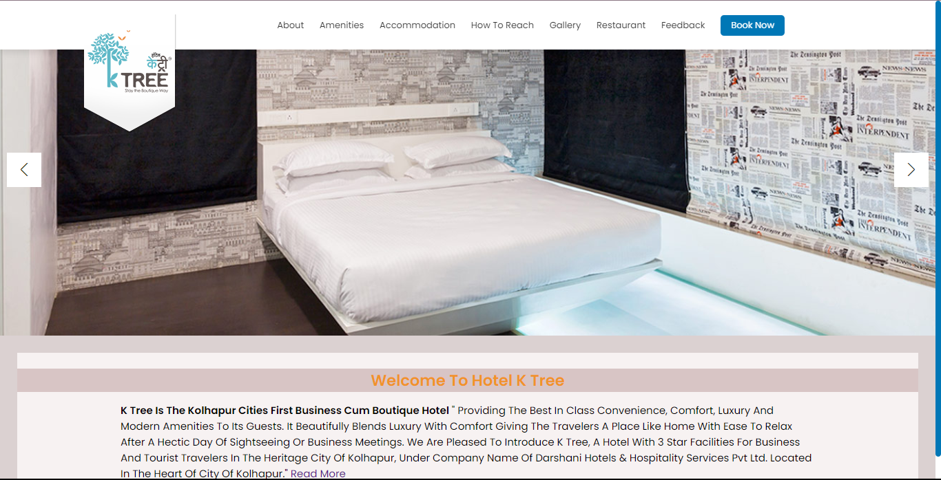

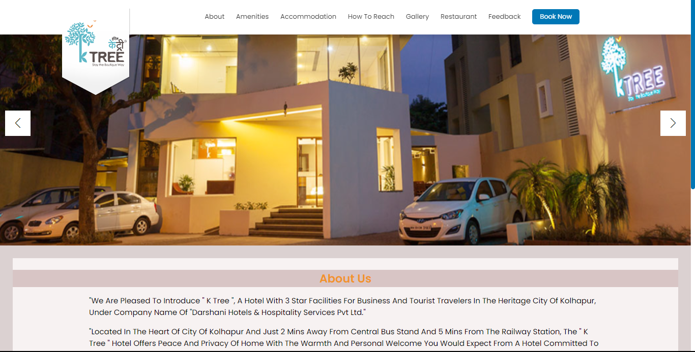

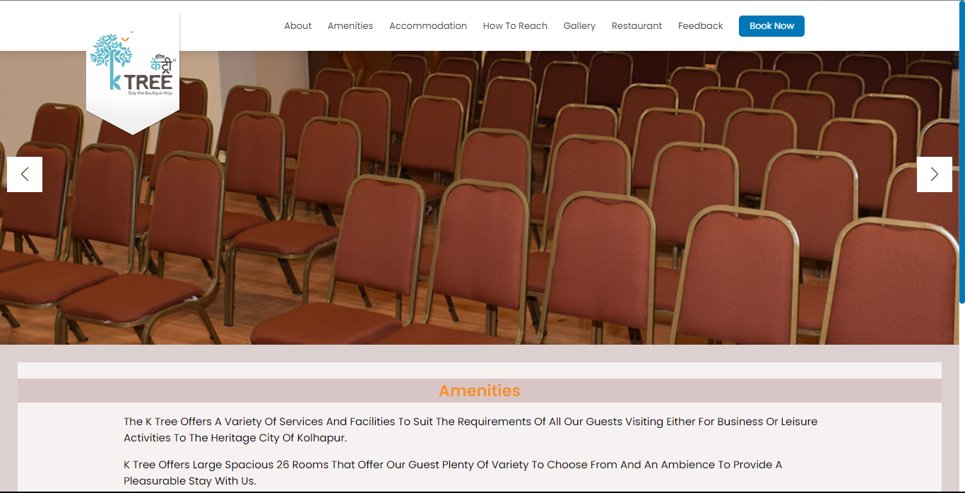

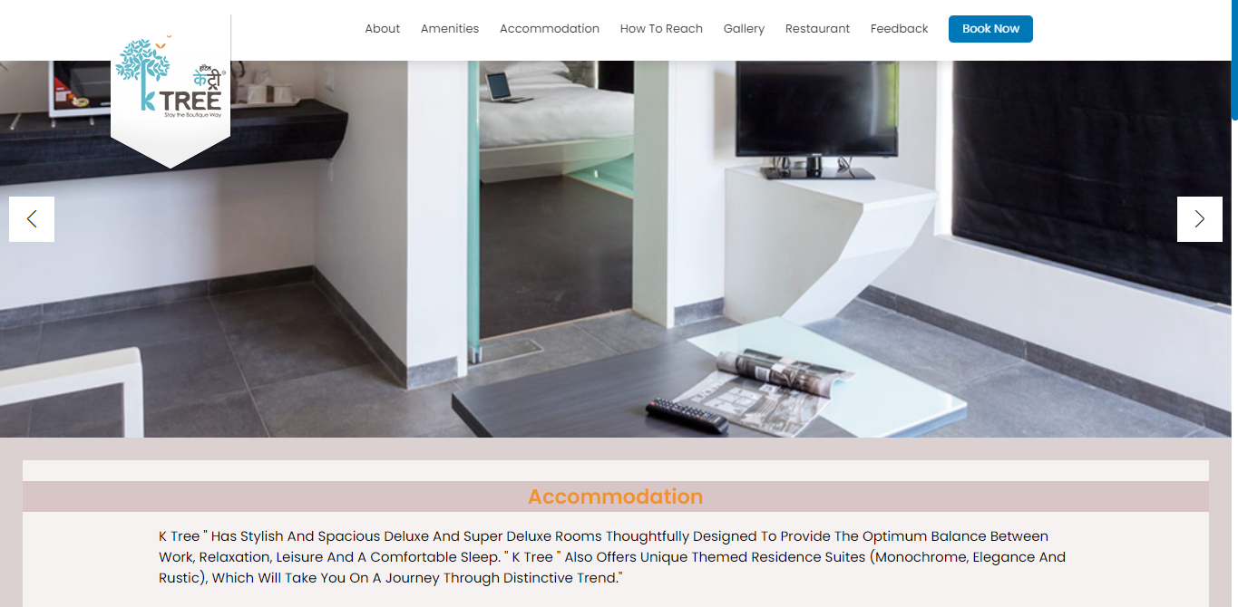

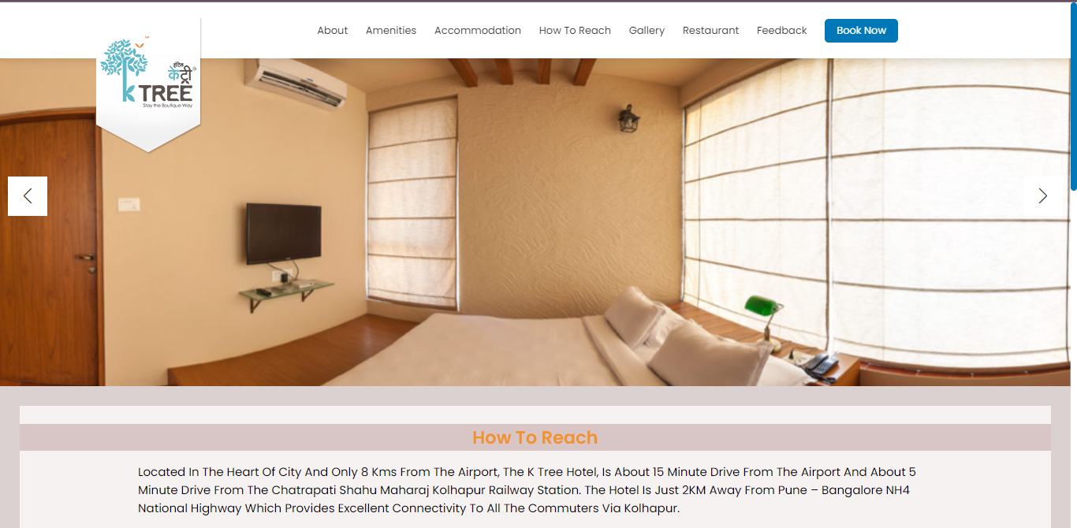

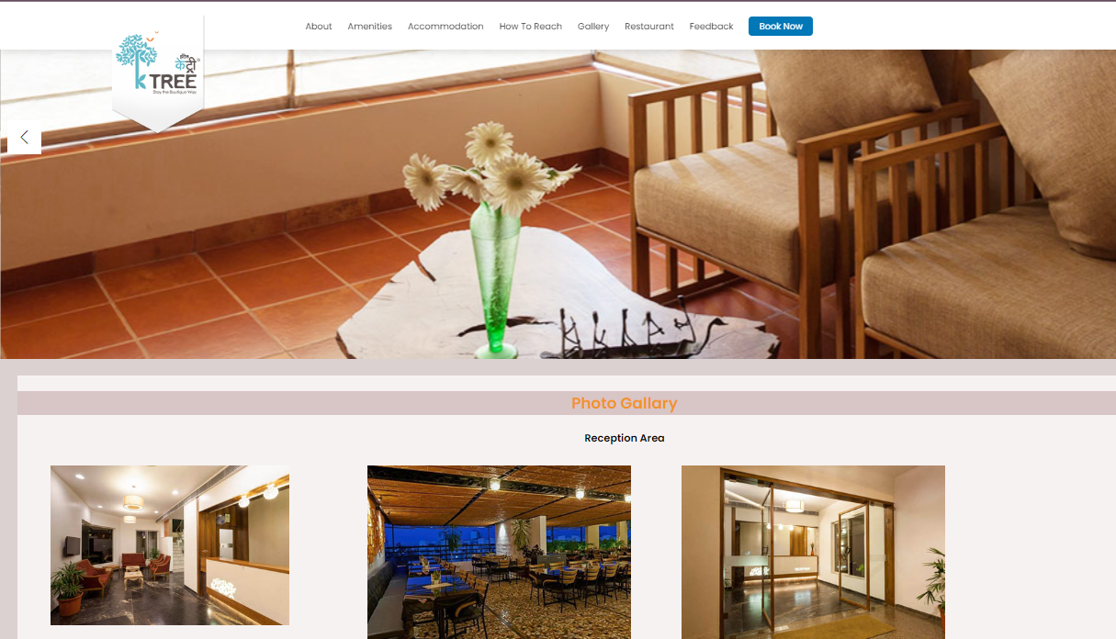

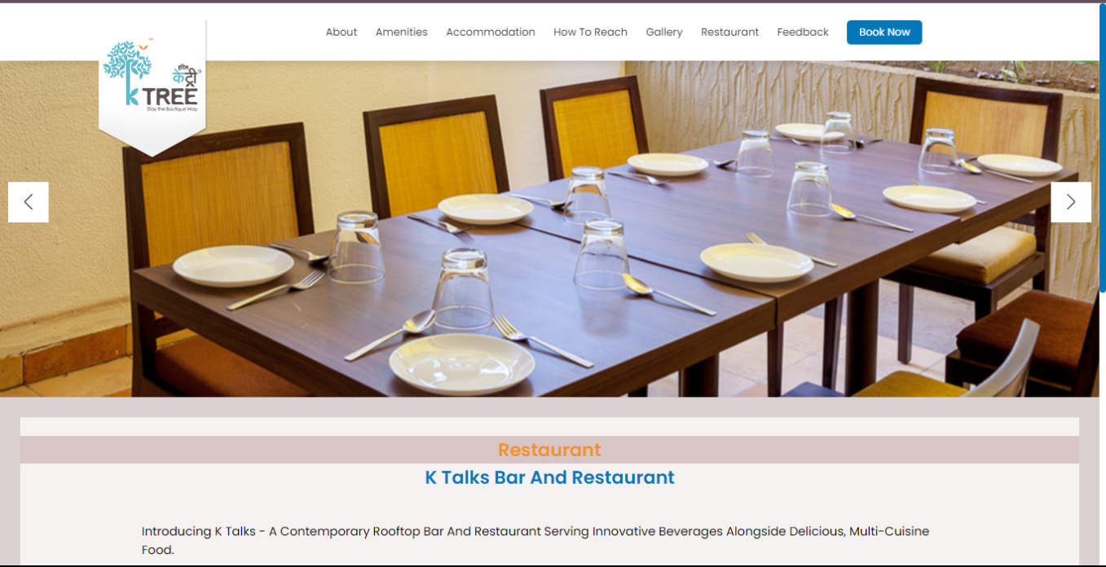

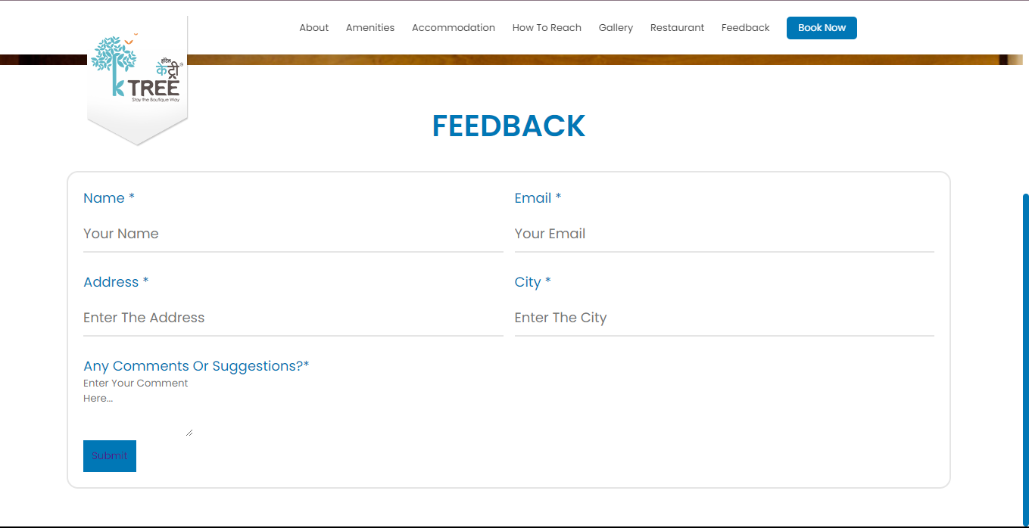

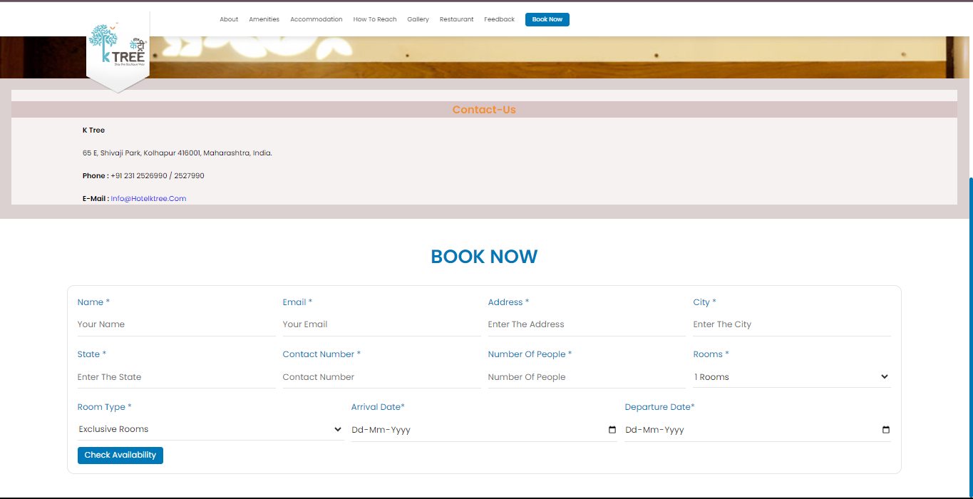

1. CONCLUSION :

In conclusion, the K-Tree Boutique Hotel project represents a significant step forward in the hospitality industry, offering a dynamic and efficient solution for collecting, analysing, and utilizing guest feedback. This project's success is rooted in its ability to bridge the gap between guest expectations and the hotel's commitment to delivering exceptional service. In essence, the Hotel Feedback Form project represents a pivotal step in the journey toward improved guest satisfaction, loyalty, and hotel competitiveness. It highlights the importance of leveraging technology to create meaningful connections with guests, transform data into insights, and drive excellence in the hospitality industry. The project serves as a testament to the industry's dedication to fulfilling guest expectations and fostering enduring guesthotel relationships.

1. BIBLIOGRAPHY:

ttps://wordpress.org https://www.sqlite.com

https://www.gnu.org/copyleft/gpl.html https://es.wikipedia.org https://w3schools.com